**Prototypes**

**Navigation:**

1. After entering Navigation on the home screen, the user is prompted to enter the destination in the search bar. The user can select from recent destinations, starred places, or home and other preset locations. Also, the user can view more and edit recent and starred locations, and edit preset shortcuts by tapping on corresponding buttons below.

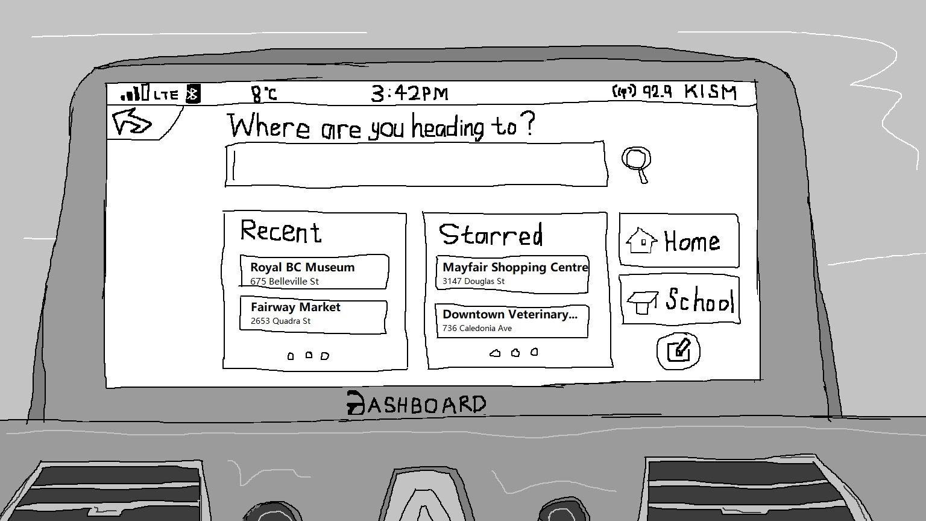

2. The user starts to input by tapping on the search bar, then a keyboard pops up. The search engine accepts both location names and addresses. Just type in few letters, the input is finished automatically, and the swipe-to-type featured keyboard shortens the input time significantly. In each of the searching results, there are three buttons: navigate, view on map, and star. If a location has already been starred, the star is shaded. Click on shaded star to unstar the location.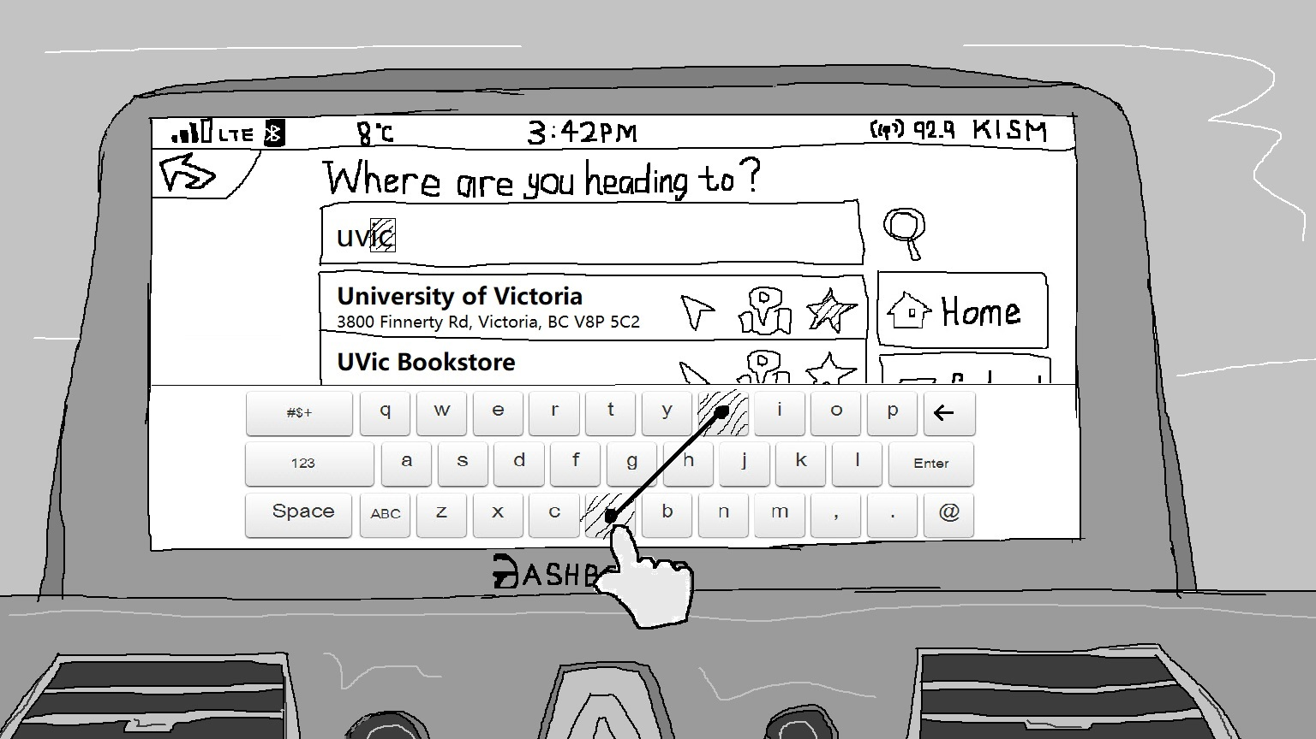

3. The user chooses to navigate, and the system tells the best route options: a route with the shortest distance, and another with the shortest travel time. A map on the right displays them visually. The user can tap on the navigate button on either option to choose and start navigating.

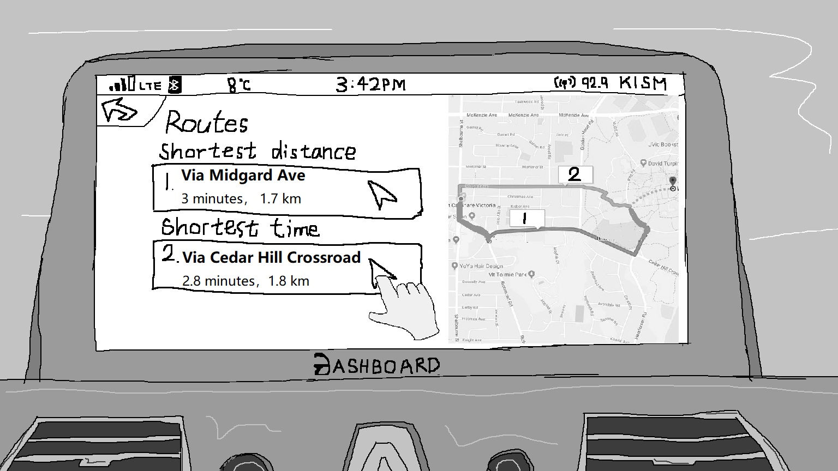

4. During the navigation, the map is fullscreened. The user can tap on Exit to quit to map-only mode, or Search to start with a new destination.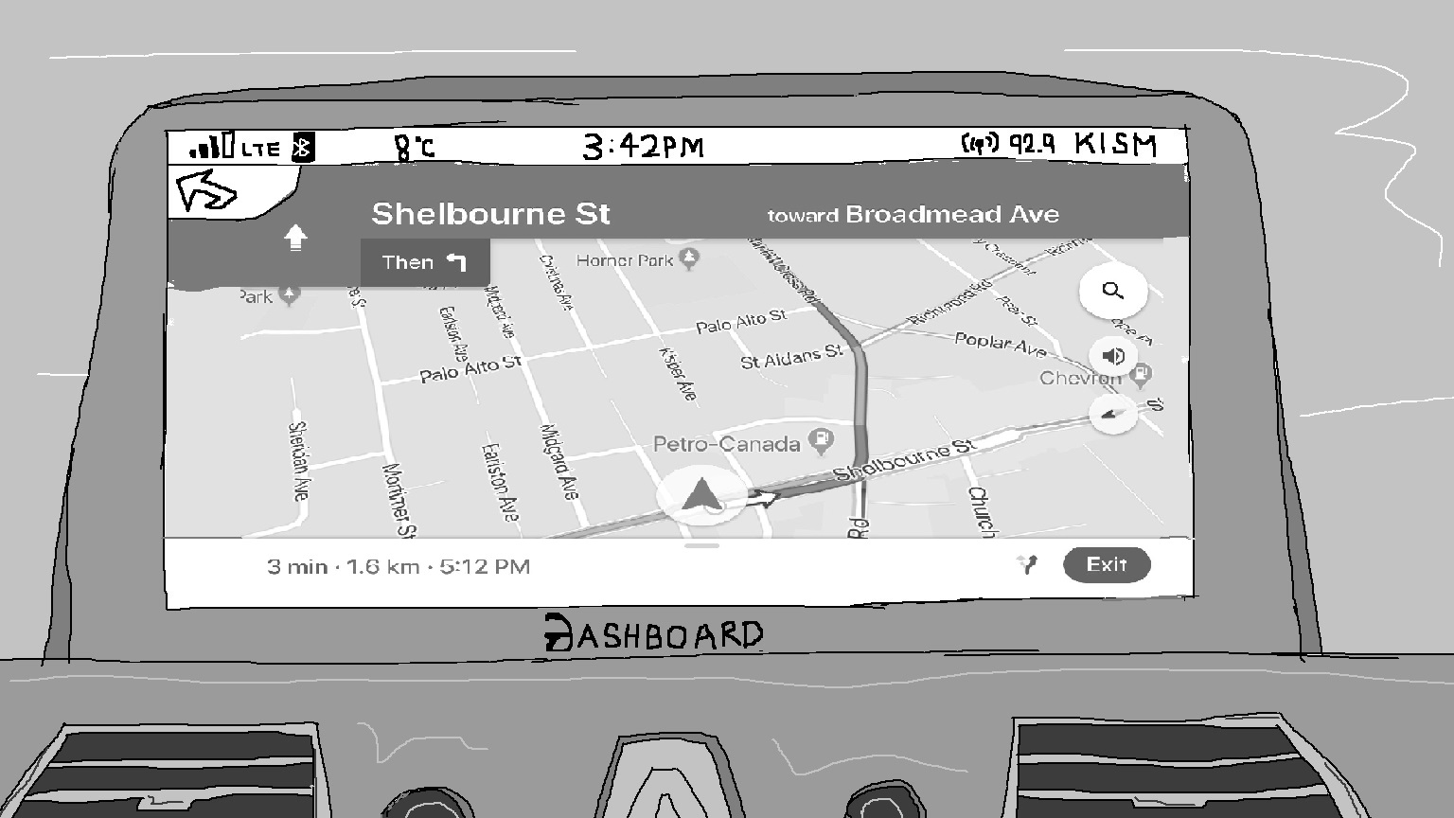

5. Simultaneously, the HUD on the windshield displays the next direction that the user will follow.

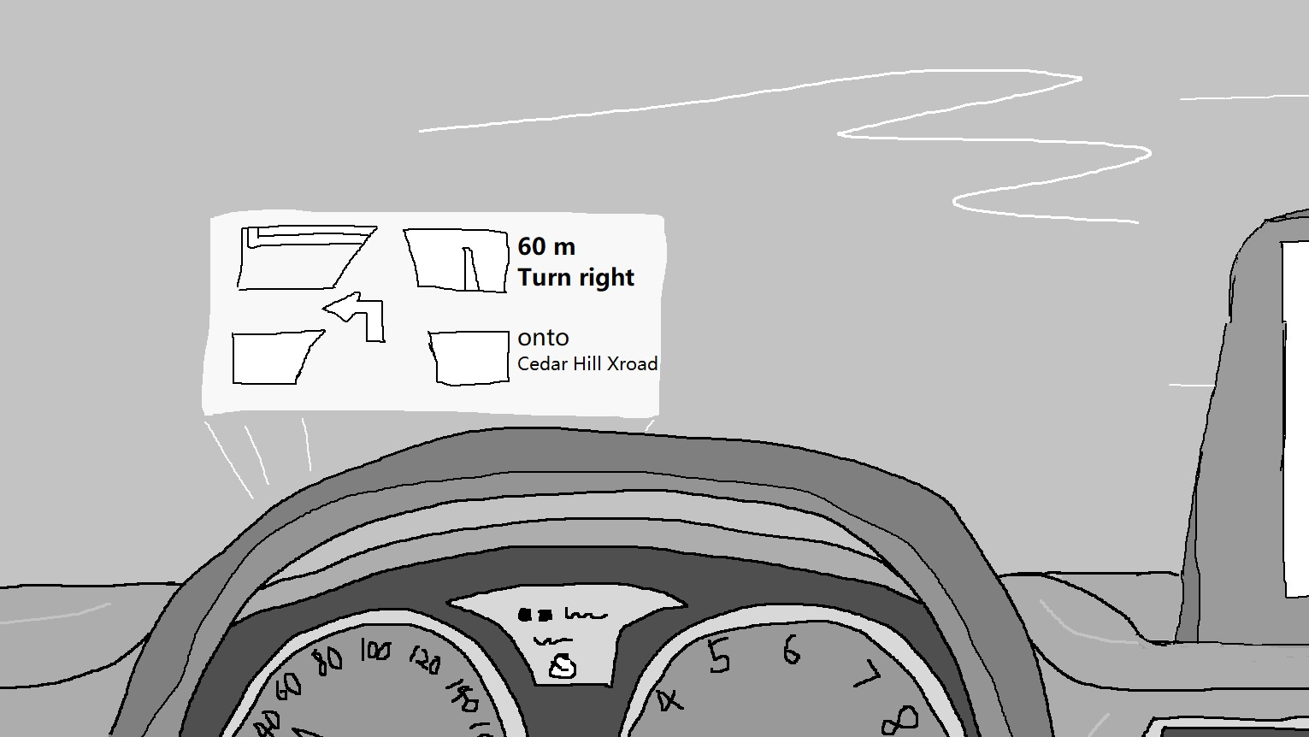

**Playing Music:**

1. From the home screen, the user selects the music icon by either tapping the screen, or swiping towards the bottom left corner.

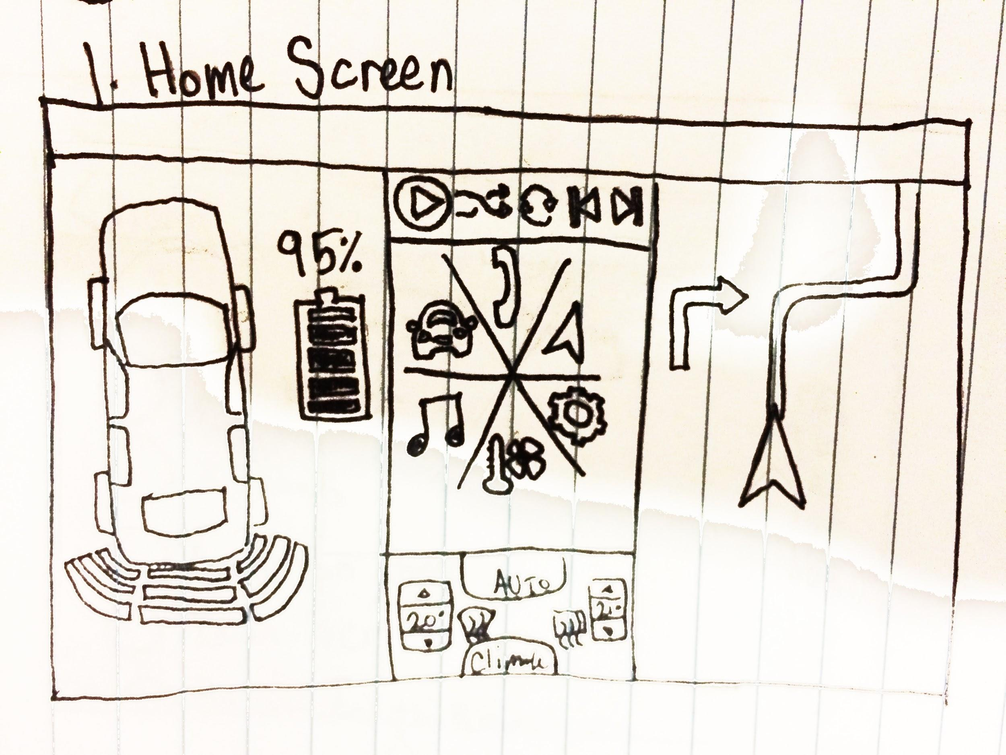

2. The system displays quick-access playlists as well as music ordered by album with the options of selecting music by song title, artist, or radio. The user can scroll sideways through their available playlists, or browse their library by scrolling downwards. The user taps the “Artist” button to view their library sorted by artist.

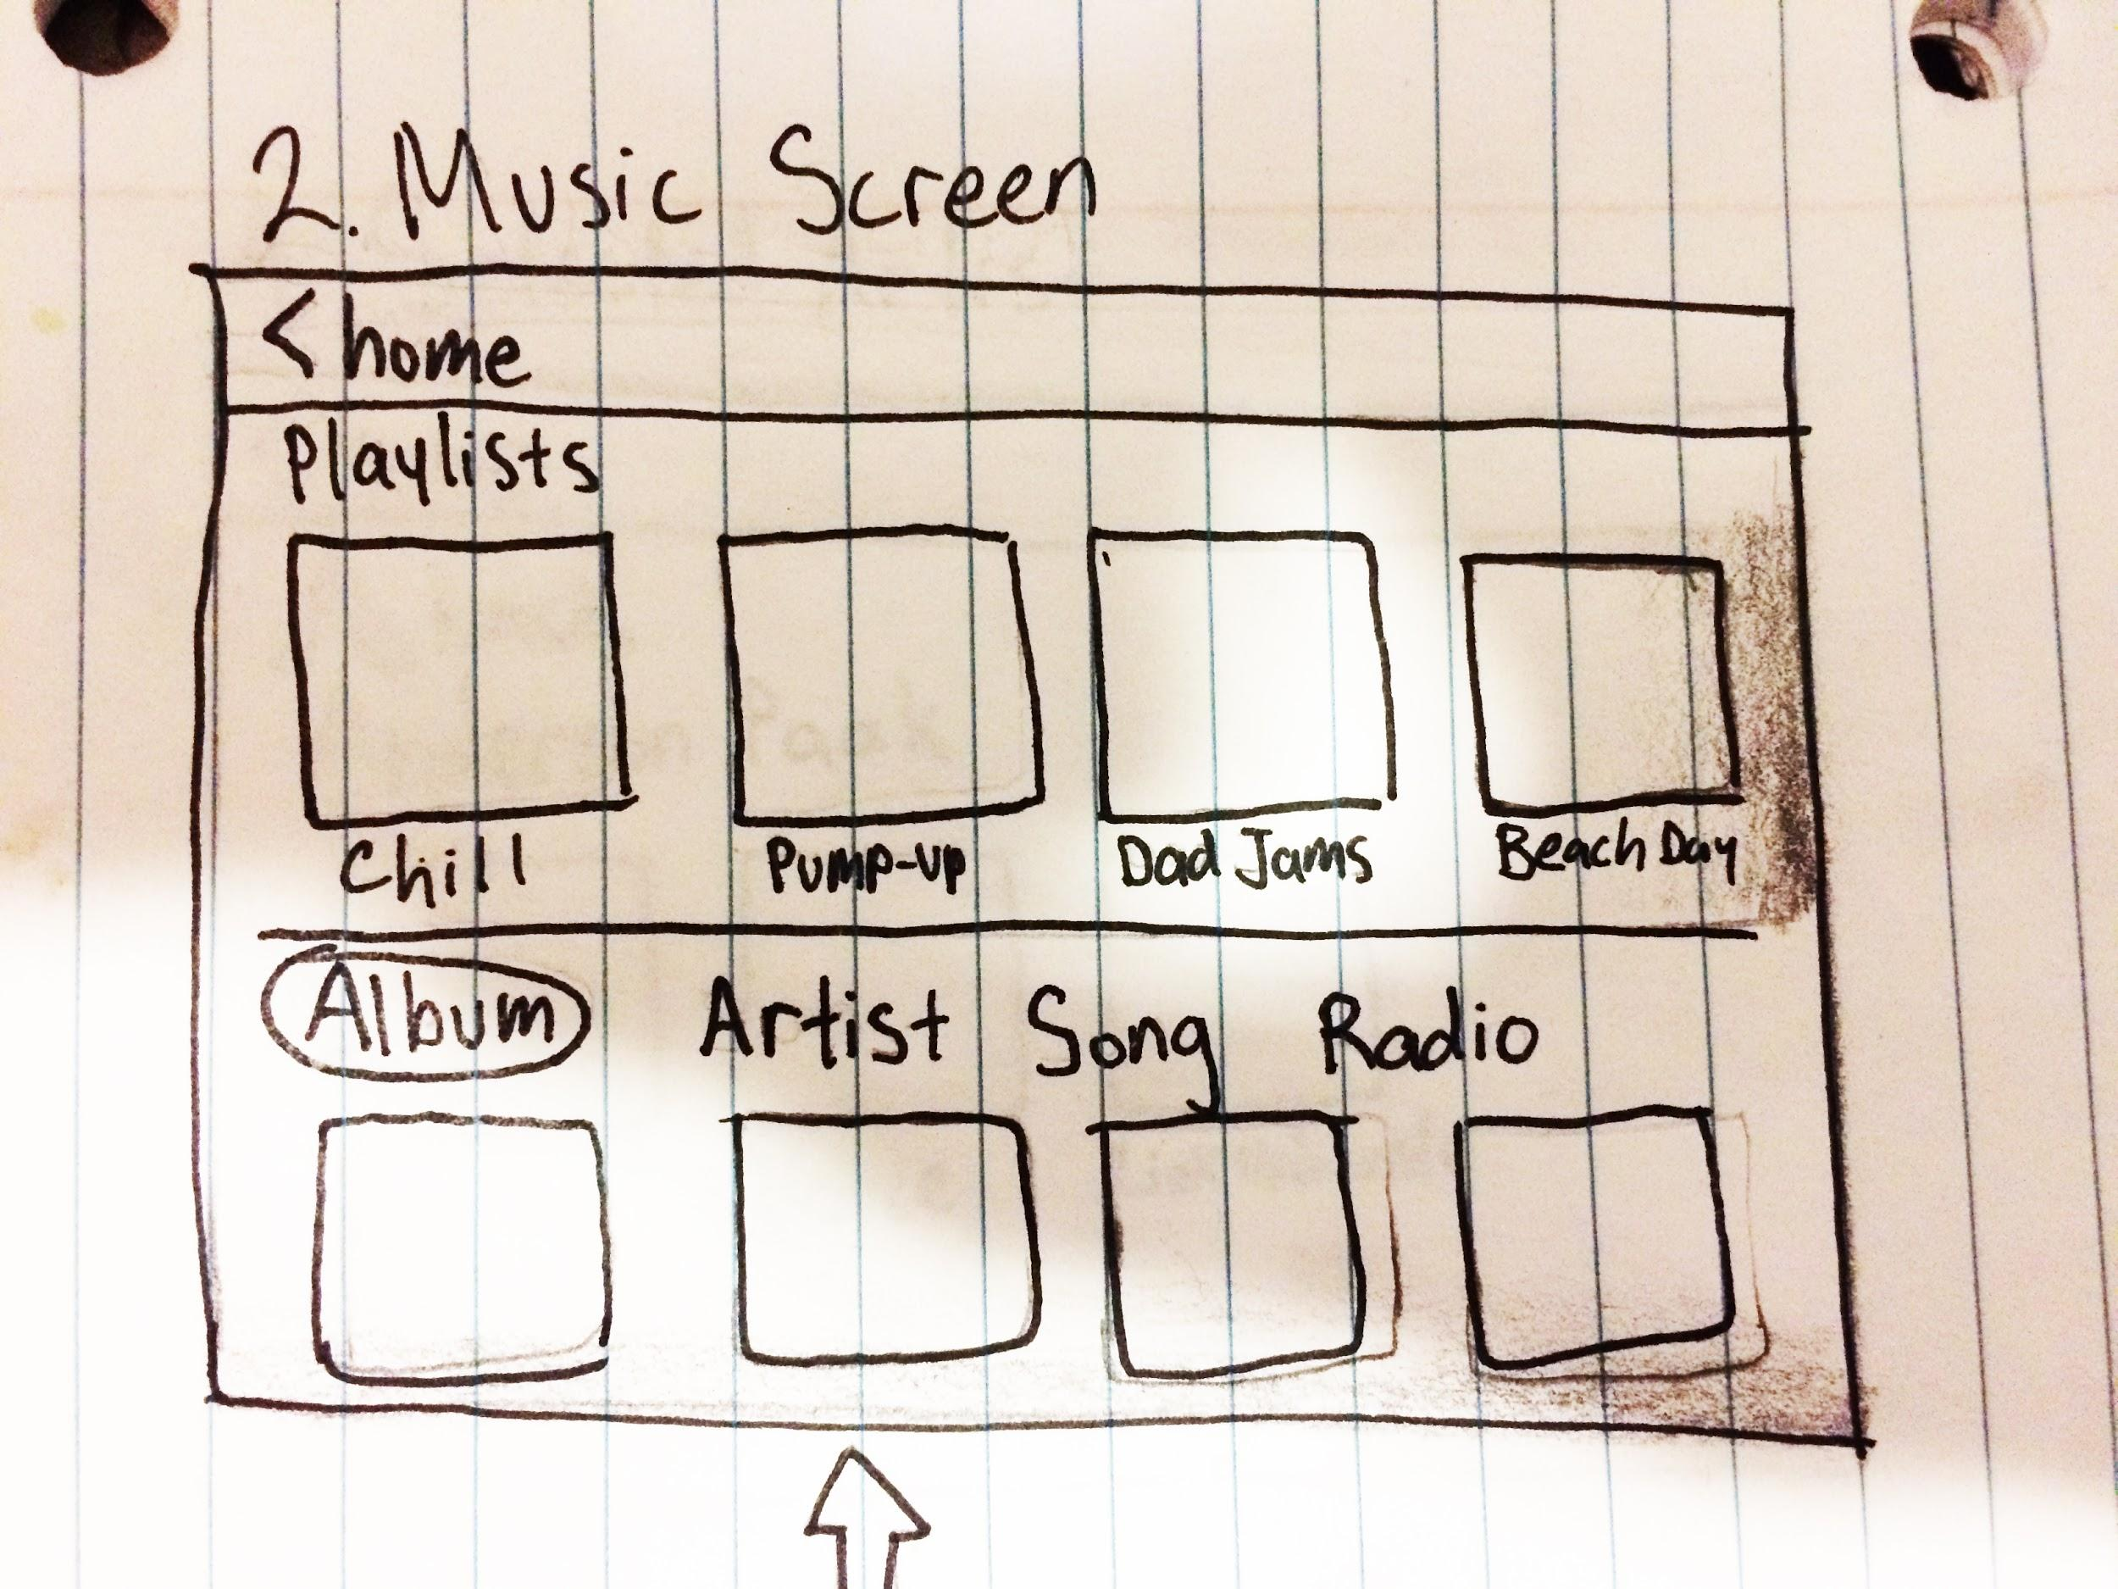

3. The user is presented with the artists contained in their music library sorted alphabetically. The user scrolls up/down to find the desired artist, then tap on their name.

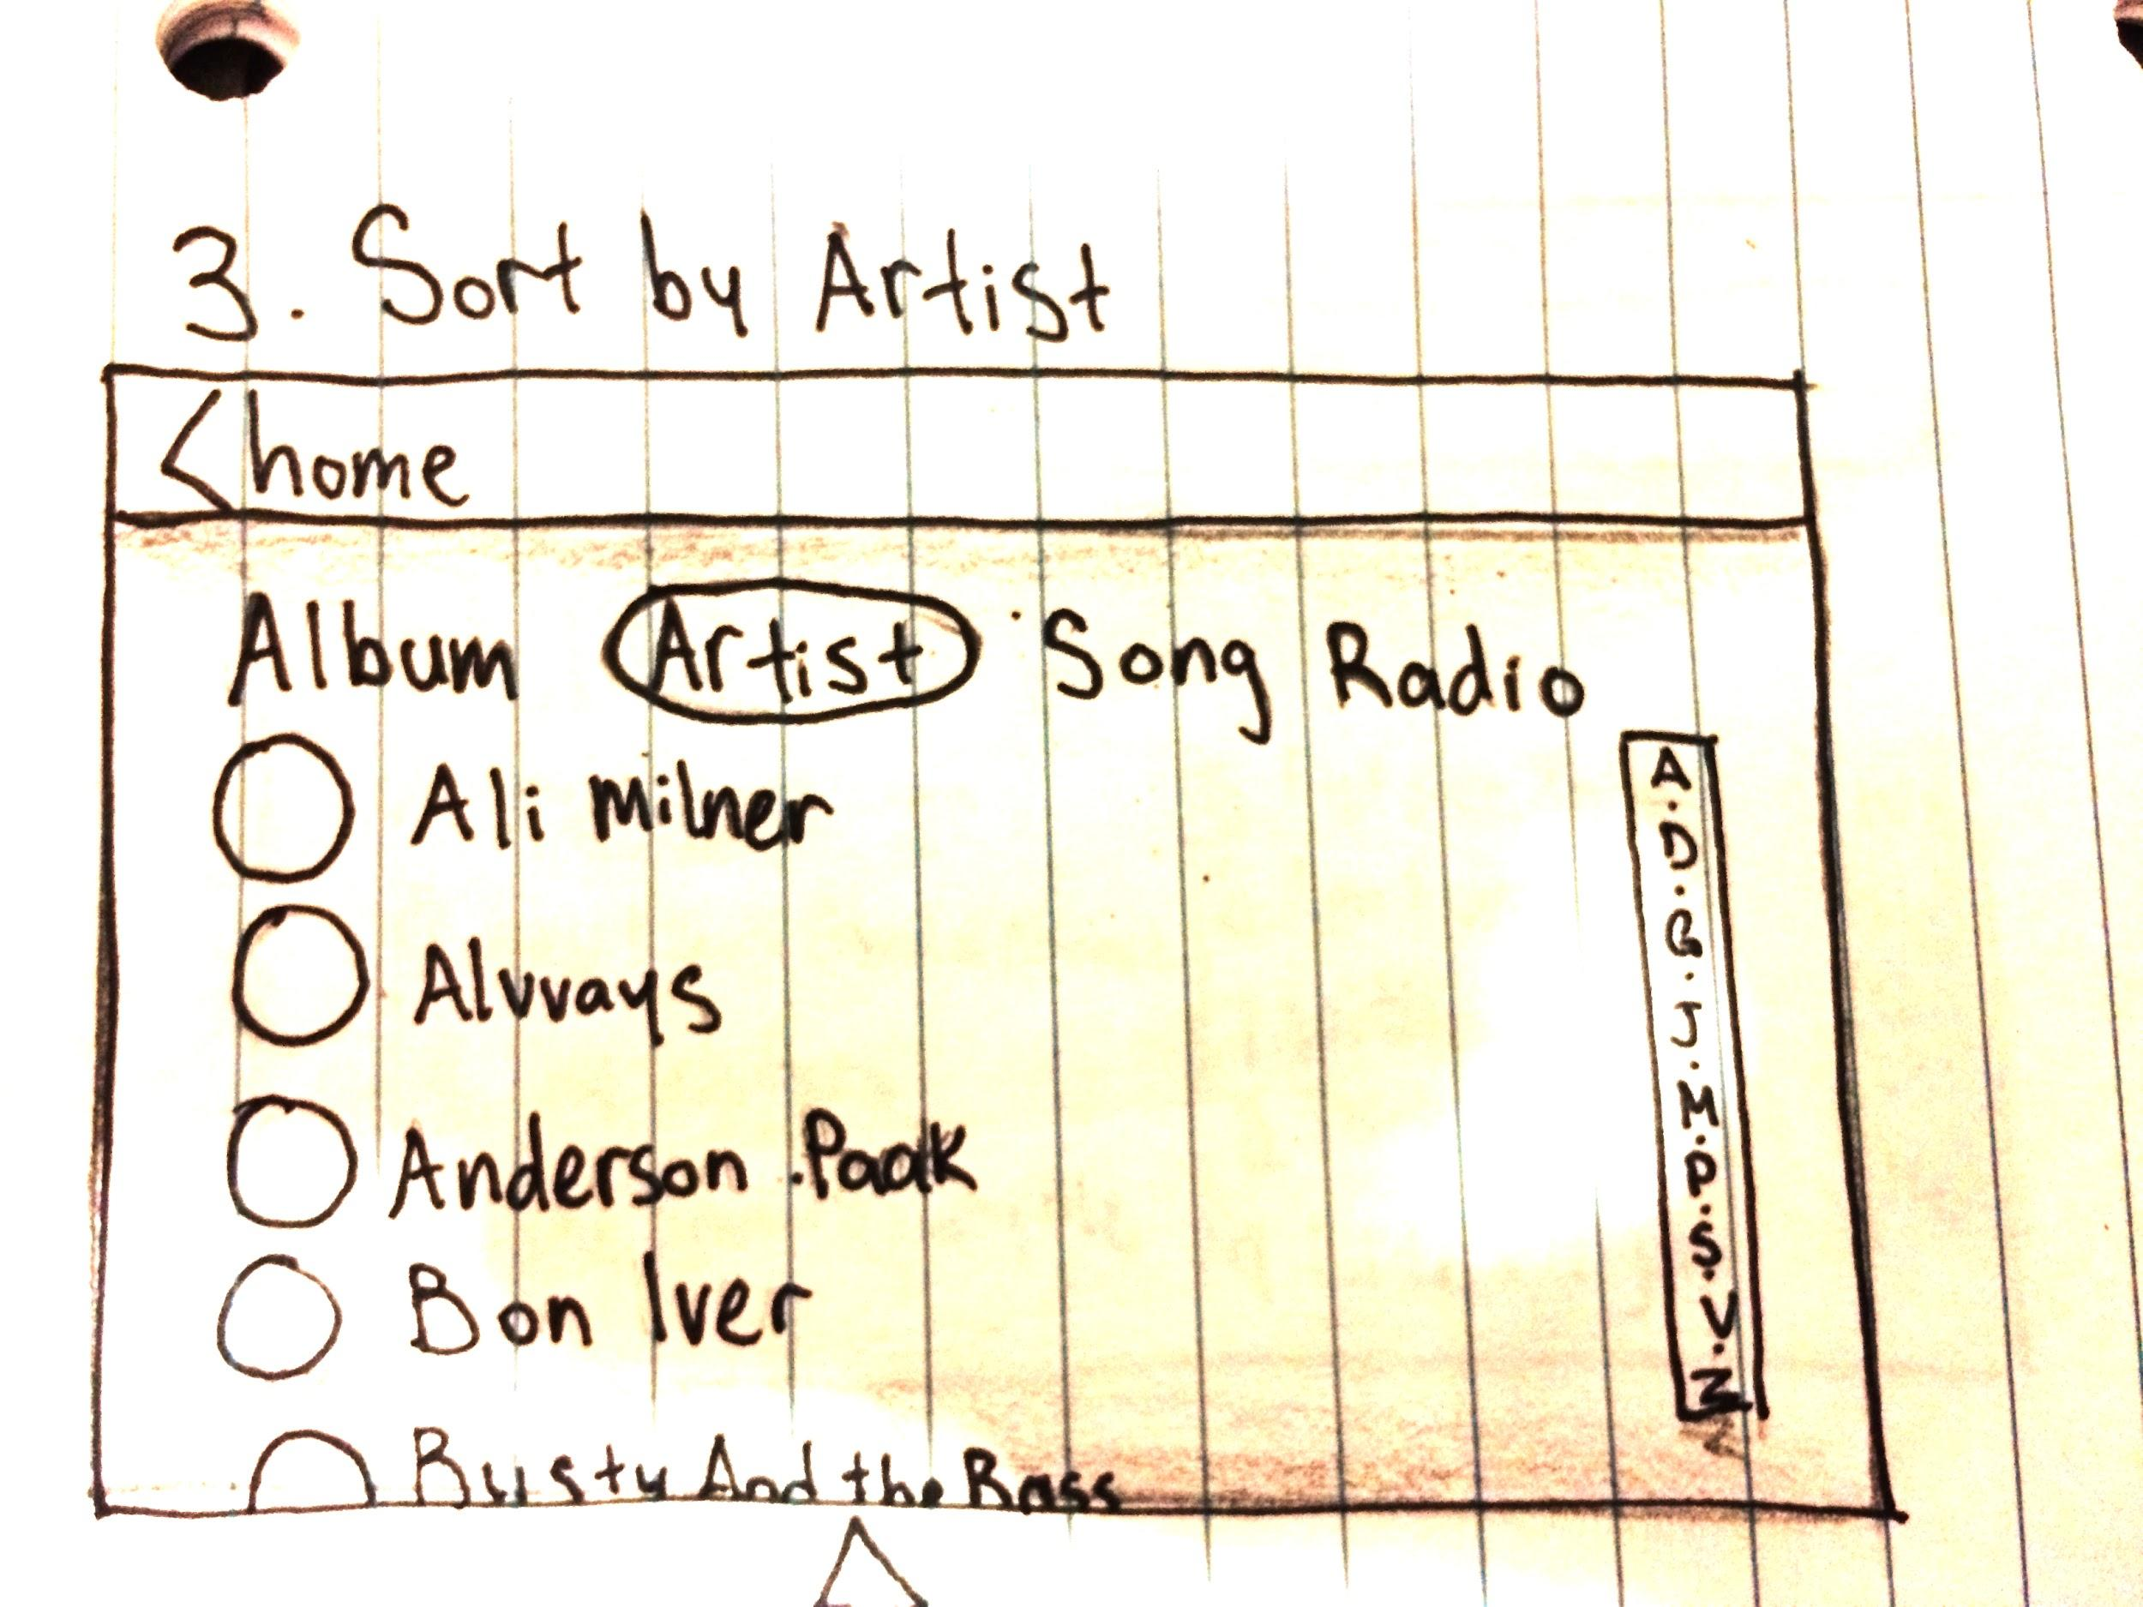

4. The user is presented with all of the albums in their library by their selected artist. They can tap on an album to view more, or tap the back button go back to the previous page. The user selects the album they would like to listen to.

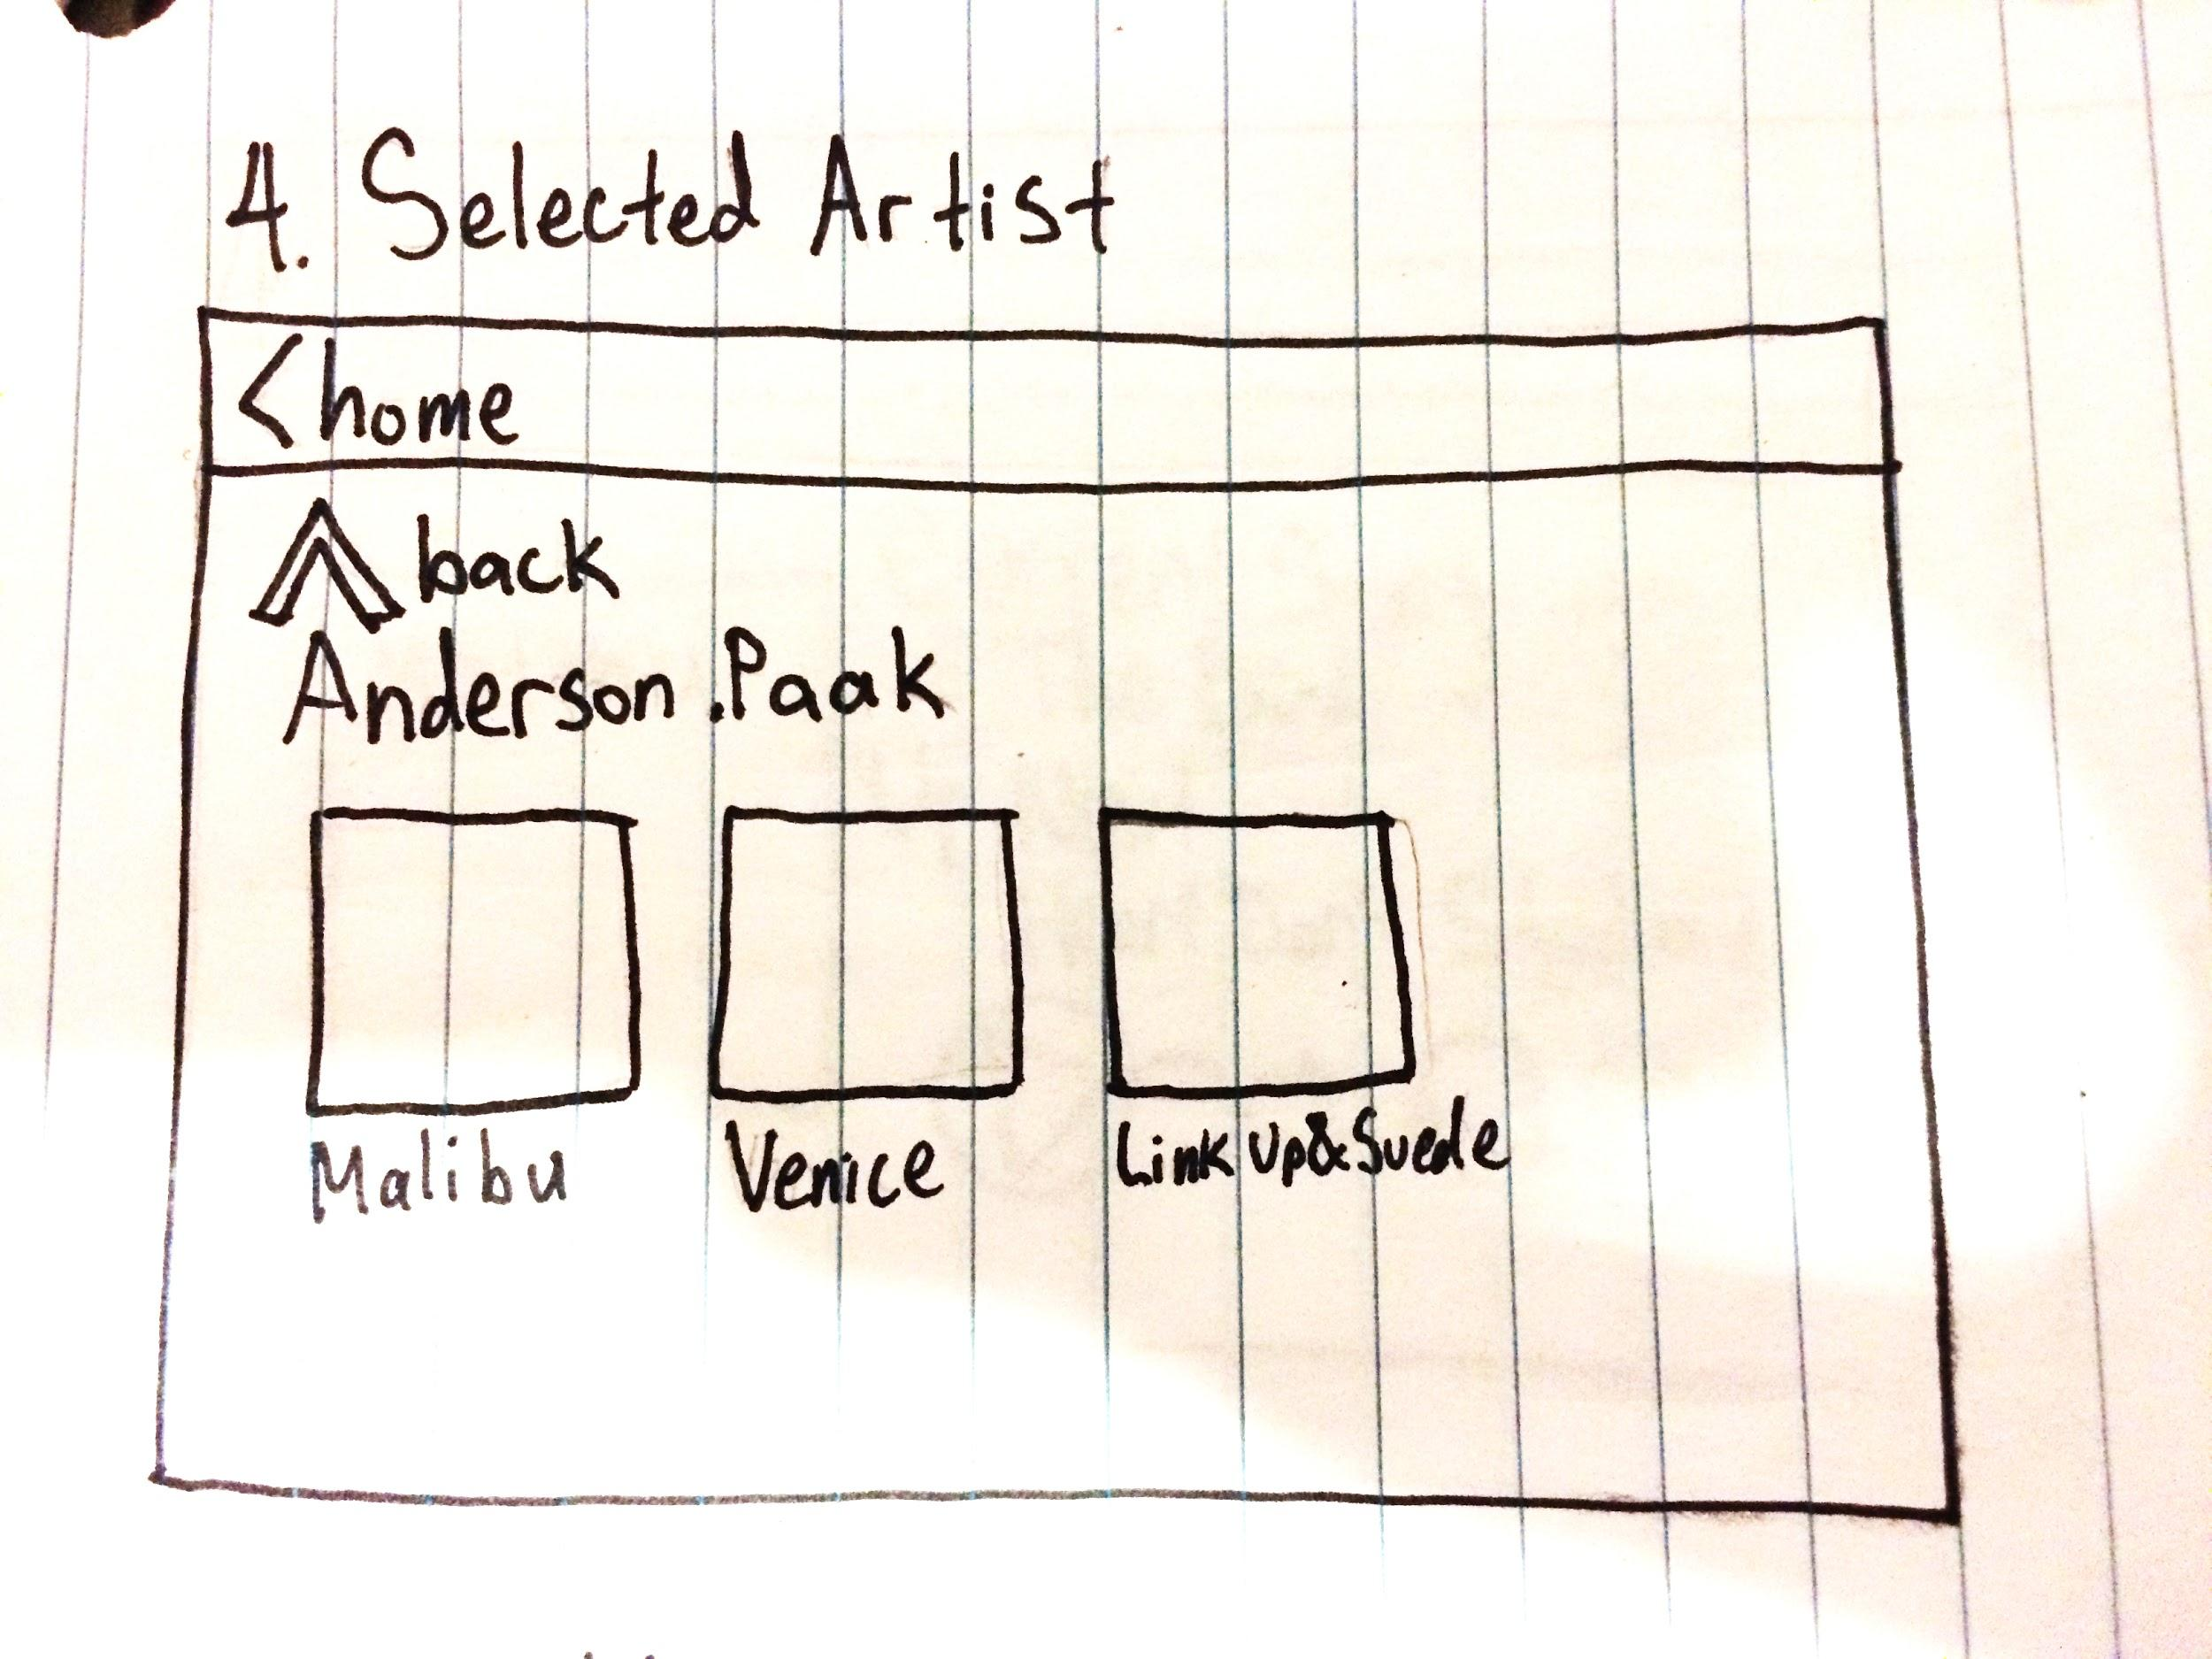

5. The user is presented with the contents of that album. They can scroll sideways to view more songs on that album, and tap on the song they would like to play. The user selects their desired song, and it starts playing immediately.

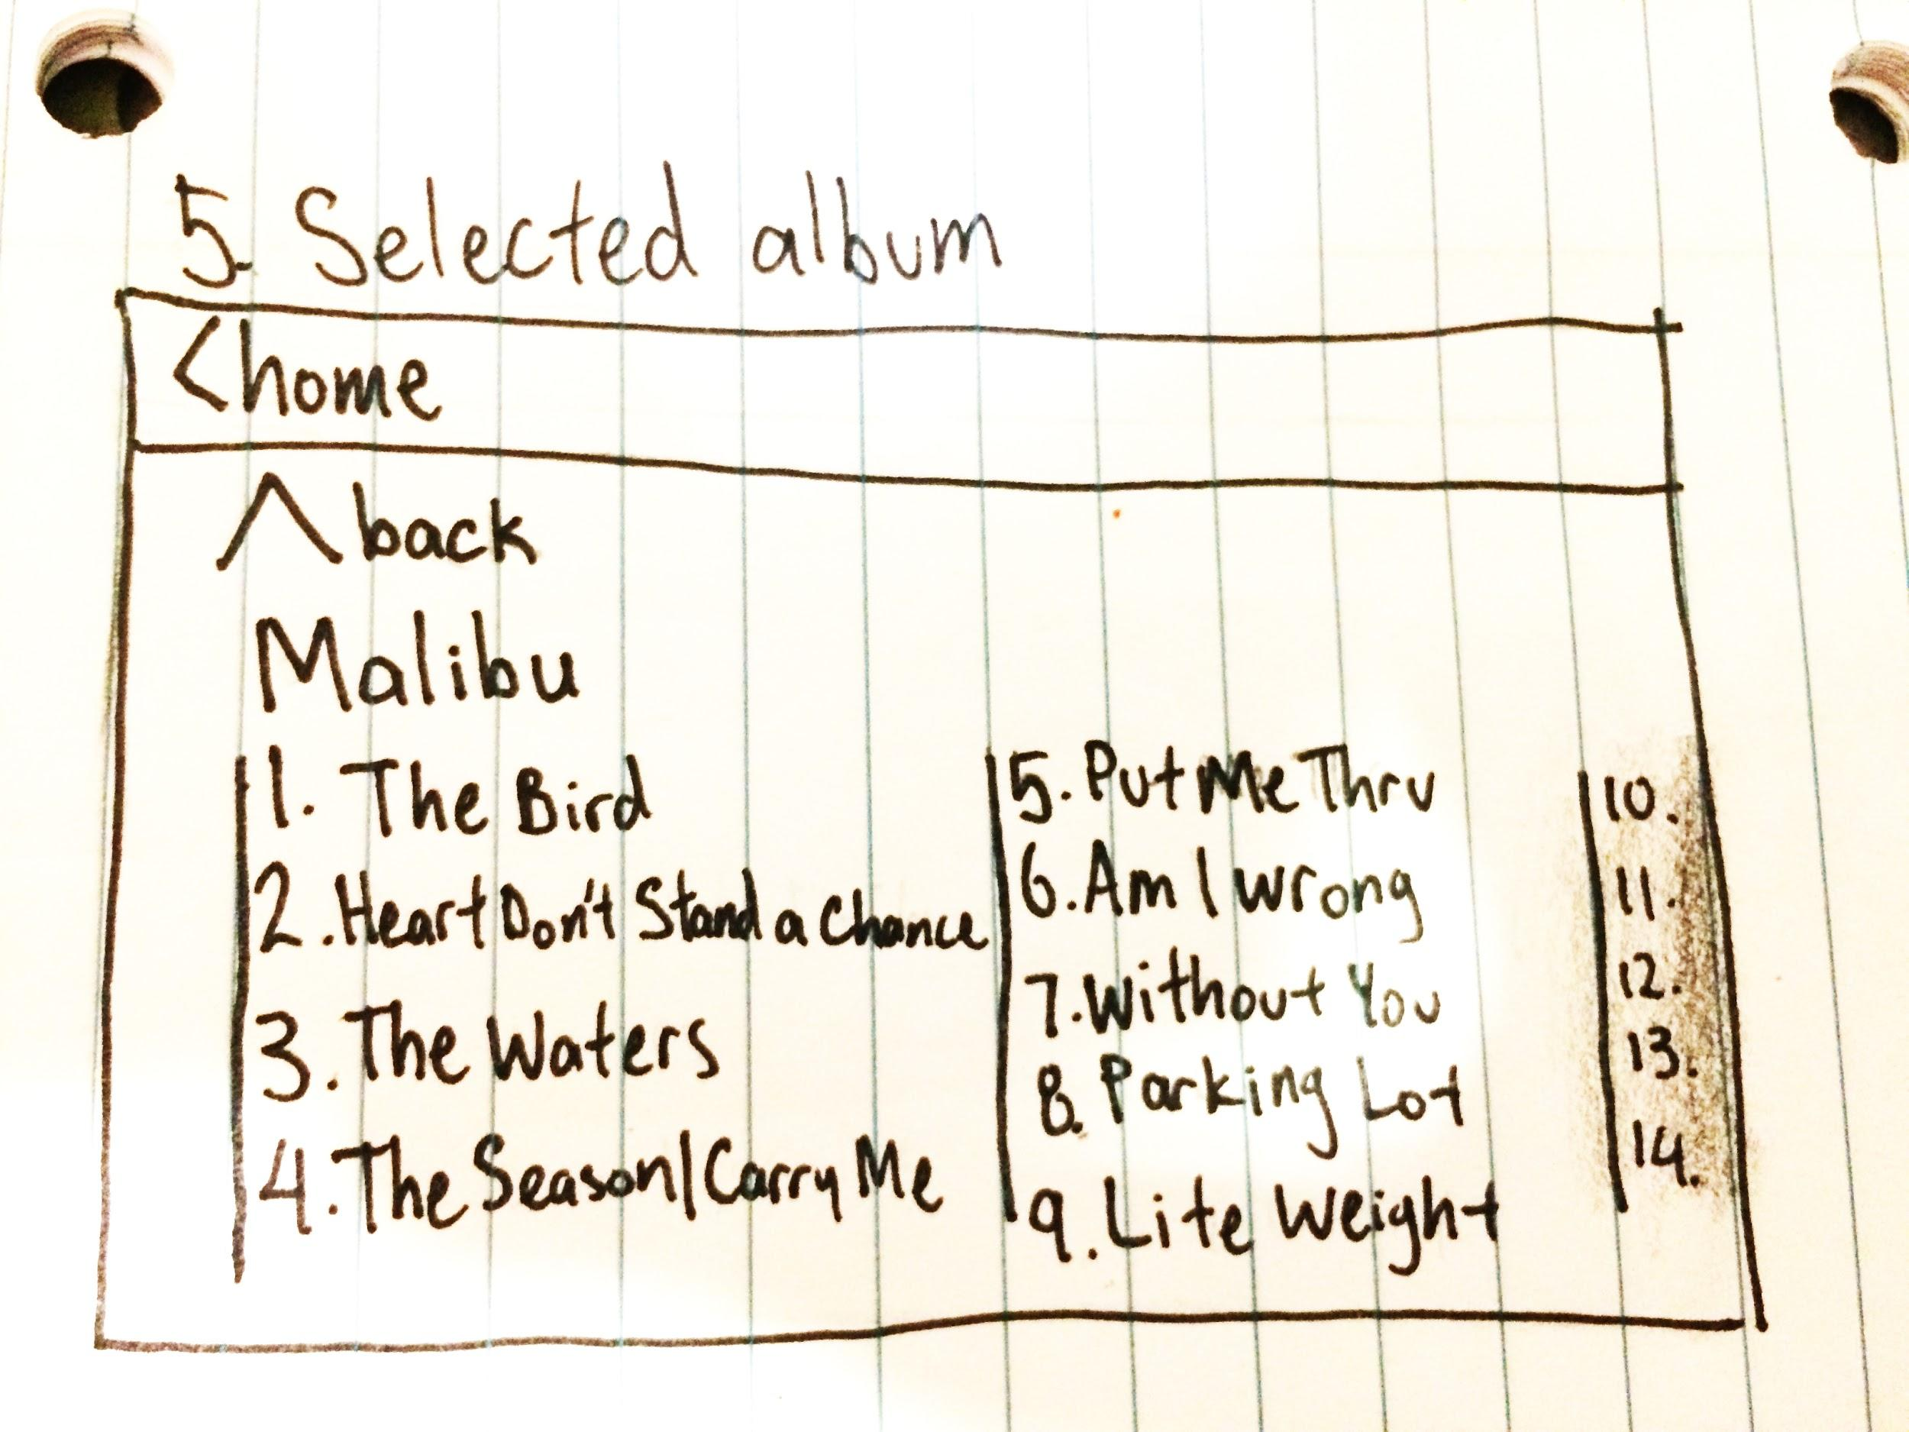

6. The user is presented with the play screen, containing the album art of the current song, the title of the current song, the title of the next song in the queue, as well as a row of buttons for controlling playback.

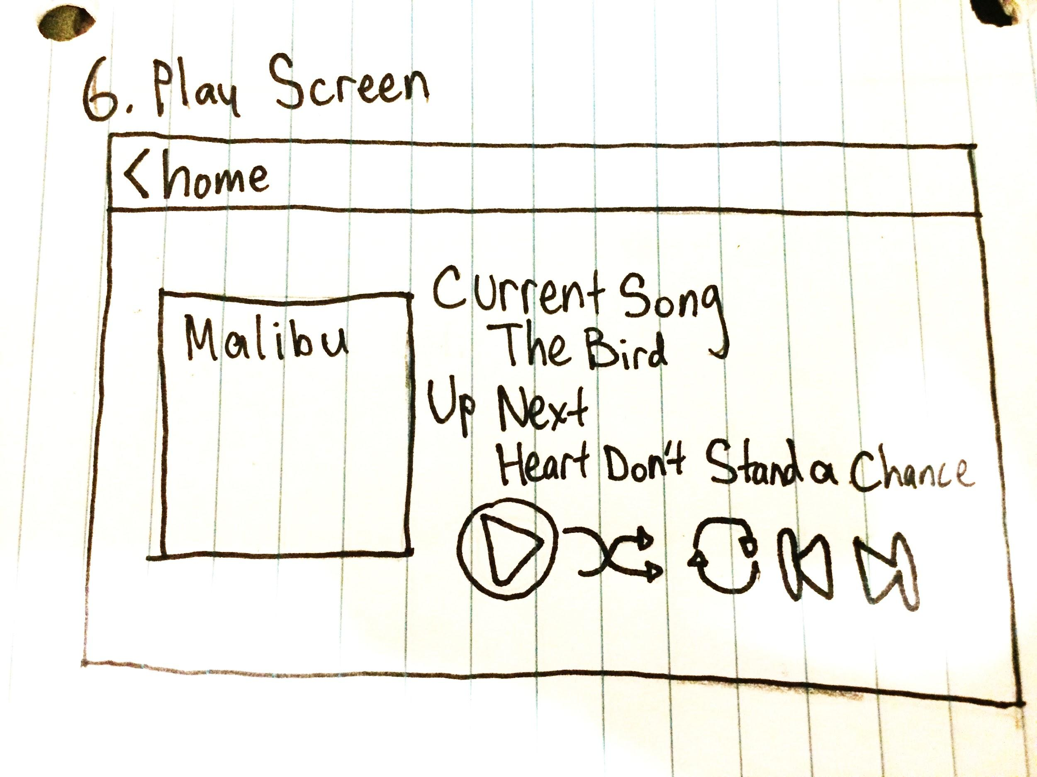

**Playing Movies**

## 

From the home screen, the user selects the application tab. The application tab contains the applications for movies, youtube, music and more. Once the app screen has loaded, the user is presented with a new screen.

## 

The loaded screen contains pre-saved movies, mediums to load movies (DVD/external storage), a link to the music app as well as the radio option. The user is left with the option of selecting the desired movie.

**File Upload**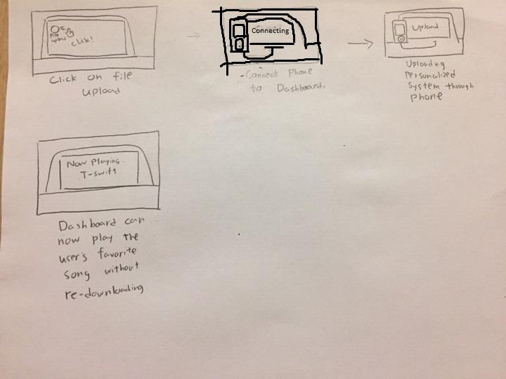

1. The user is presented with an option to personalize their dashboard the way they want it to look, as well as other options such as music preferences. The user accesses this by clicking on the personalize option on the dashboard menu.
2. The user then connects their device with the dashboard to initiate the personalization.
3. The device will start uploading personalized options to the dashboard (e.g. favorite music playlists, preferred backgrounds...etc).
4. The dashboard is now personalized.

## 

## Personas and Scenarios

|  |  |
| --- | --- |
| Persona | Young professional |
| Photo |  |
| Fictional name | Taylor McGill |
| Job title | Sales Manager, AT&T |
| Demographics | 28 years old  Single  Lives in California  BSC in economics |
| Goals and tasks | Taylor wants a futuristic, technologically advanced vehicle - unlike her current vehicle that she feels is outdated. Wants to be able to do as much as possible without needing to add more devices to her car. |
| Scenarios | After buying a new car with Dashboard in place Taylor now uploads her files from her other devices to the Dashboard system.Taylor then plays her favourite songs without having to connect her old device. Taylor also uses the built in navigation system to help her get where she is going and no longer relies on using her phone, significantly decreasing her distractions while driving. |

|  |  |
| --- | --- |
| Persona | Upper Middle class family - Father |
| Photo |  |
| Fictional name | Bob Lee |
| Job title | Business Owner - multiple coffee shops |
| Demographics | 40  Father of two, married  Lives in Coquitlam  MSC in Business Analytic |
| Goals and tasks | Bob would like to buy a new vehicle for his wife that would be used as transportation for his wife and kids. The vehicle should help his wife transport the kids and ensure that they do not distract her while she is driving. |
| Scenarios | Bob purchases a vehicle which uses the dashboard features. He then uploads various shows and movies to the system which can then be played on the screen behind the driver. The children then select and watch whichever videos they want for the duration of the trip. These videos now distract the children so that they aren’t distracting the driver. |

**Use Cases**

**File Upload**

1. The user connects the media device to the vehicle through a wireless or wired connection.
2. The vehicle discovers the device and a notification for file management on the Central Control is given.
3. The system displays a list of contacts (if there are any), music, videos and other files.
4. The user selects the files to be transfered.
5. The user touches the confirm button to start transfer.
6. The system confirms once the files have been successfully transferred.

**Playing Music**

1. From the home screen the user selects the music icon.
2. The system displays quick-access playlists as well as music ordered by album with the options of selecting music by song title or artist or Radio.
3. The user selects the option to re-order music by artist.
4. The system displays a list of alphabetically sorted artists.
5. The user selects the desired artist.
6. The system displays all albums by the selected artist.
7. The user selects the album.
8. The system displays the songs in the album.
9. The user selects the song to be played.
10. No confirmation is needed as the music starts to play.

**Playing Movies**

1. From the home screen the user selects the movie icon.
2. The system displays all movies ordered alphabetically.
3. The user selects the desired movie to be displayed on the rear monitors.
4. The videos begins to play.
5. The back seat passenger taps the screen.
6. The rear monitor displays a scrub bar with movie control icons.
7. The passenger scrubs to where they left off in the movie.

**Navigation**

1. From the home screen the user selects the navigation icon.
2. The system displays a navigators search bar along with starred locations and a map.
3. The user then inputs the address into the navigators search bar.
4. The user taps “get directions”.
5. The system generates a route for the user to take.
6. The user presses confirm to set the route.
7. The system displays next direction onto the hud for the user to follow.